**PROJECT REPORT:**

**GOOGLE CLASROOM**

**NAME: ISHTIAQ HUSSAIN**

**ROLL NO: 22I-0549 (CS-E)**

**COURSE: OBJECT ORIENTED PROGRAMMING**

**UML DIAGRAM:**

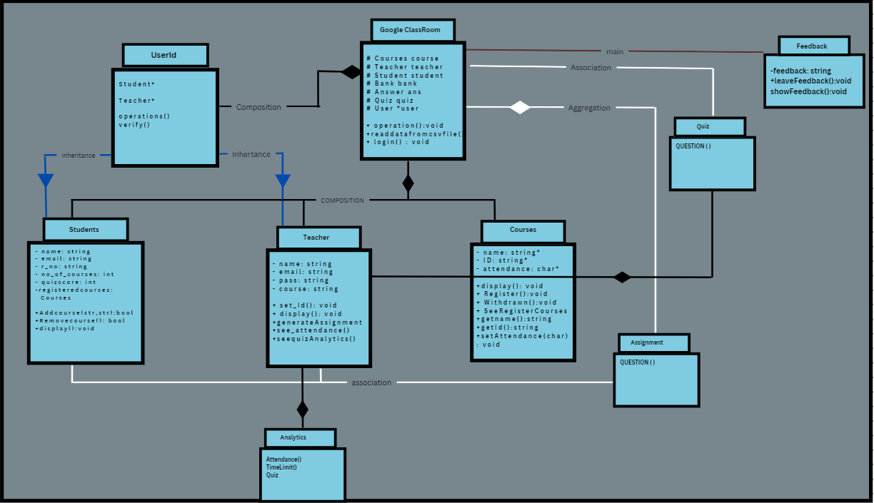

**Code** **Implementation:**

Used concepts of **Composition** mostly, with **aggregation** in some parts and **Inheritance** in Users to Student and Teacher. Haven’t used any static members (could have used for total no of students registered, but didn’t felt like the need to)

→ My main class is **GoogleClassroomSystem** in which all the data is stored from file reading.

→Read Data file to store Students/Teachers/Course data into corresponding objects

→Read QuestionBank to store Questions into different objects such as MCQ, T/F, Q/A

→Every course has 3 different Question Object (3 representing different course names) and in each object, a set of MCQ/TF/Q/A is stored

→Read Answers file to store Answers, every course has different Answer object for different topic.

→ Now, user tries to login and if he/she is verified, he/she is then given address of student/teacher, after which a main menu opens that is different for teacher and student.

**TEACHER OUTPUT SAMPLE:**

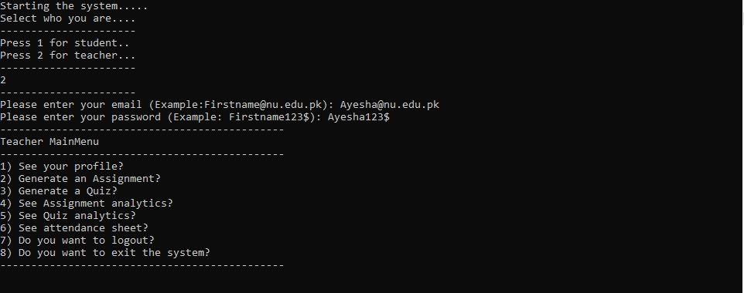

**Student OUTPUT SAMPLE:**

